Aastha's Library : Project Documentation
Name : Aastha Dhavan SAPID : 590015115 Batch : 2 [DevOps]

1. Opening Page Description & Screenshot
The opening screen serves as the gateway to the Library Management System.
- Landing Homepage: Designed using clean slate and terracotta orange highlights. It features a top navigation bar (anchored for smooth-scrolling to Services, How It Works and Library Spaces), a dynamic breadcrumb locator bar (Portal > Home), a quick catalog category preview deck and a modern flat library illustration.
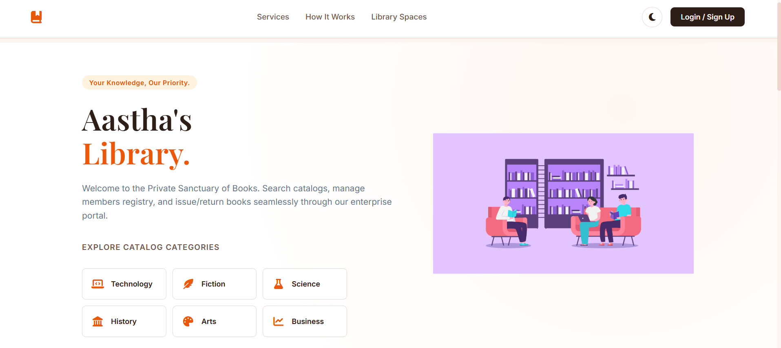
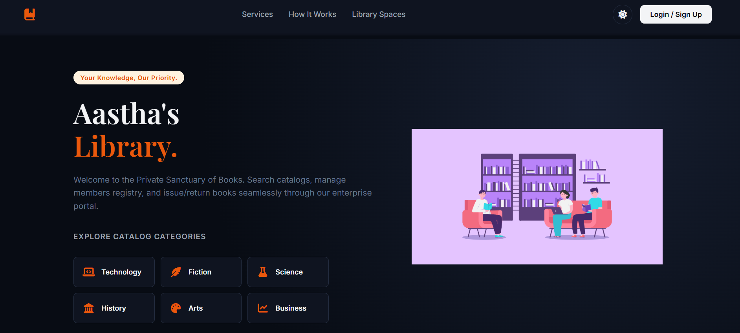
- Administrator Portal Access: When an administrator clicks Login / Sign Up, a full-screen split layout is displayed. At the top of the credential card, a breadcrumb (Home > Sign In or Home > Register) allows the user to route back to the homepage. The right panel dynamically swaps flat illustrations:
  - Sign In Tab: Displays a reading illustration (library_login.png).
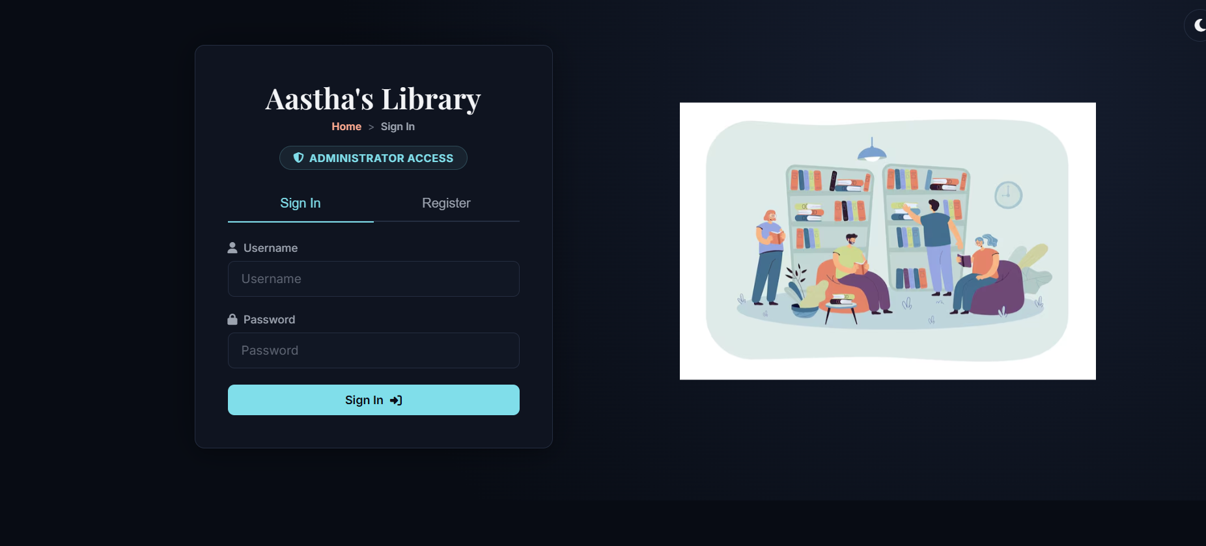
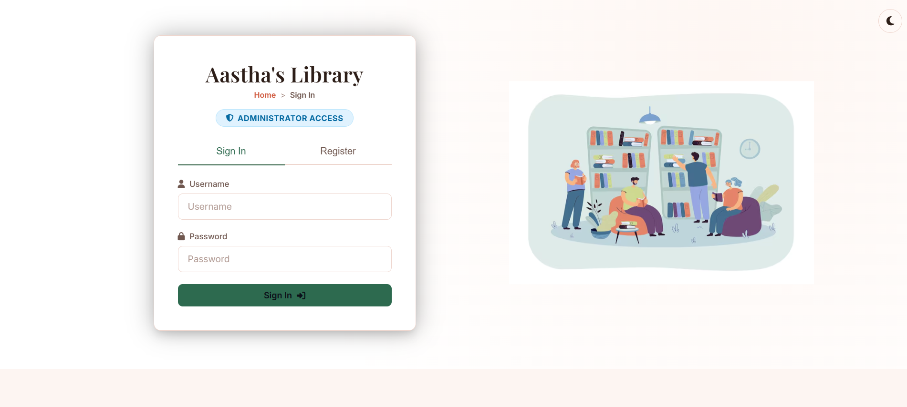

  - Register Tab: Displays a library administration layout (library_register.png).
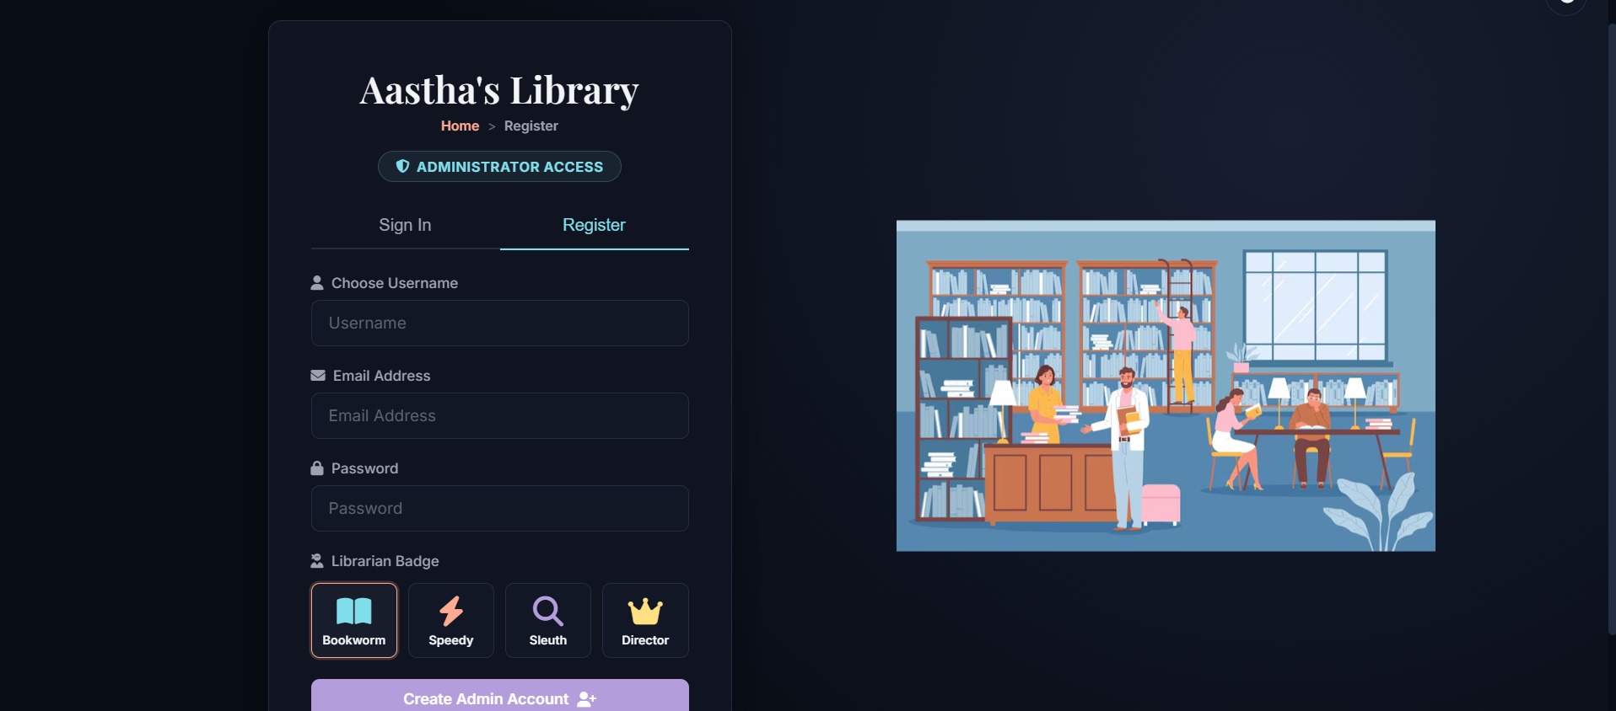
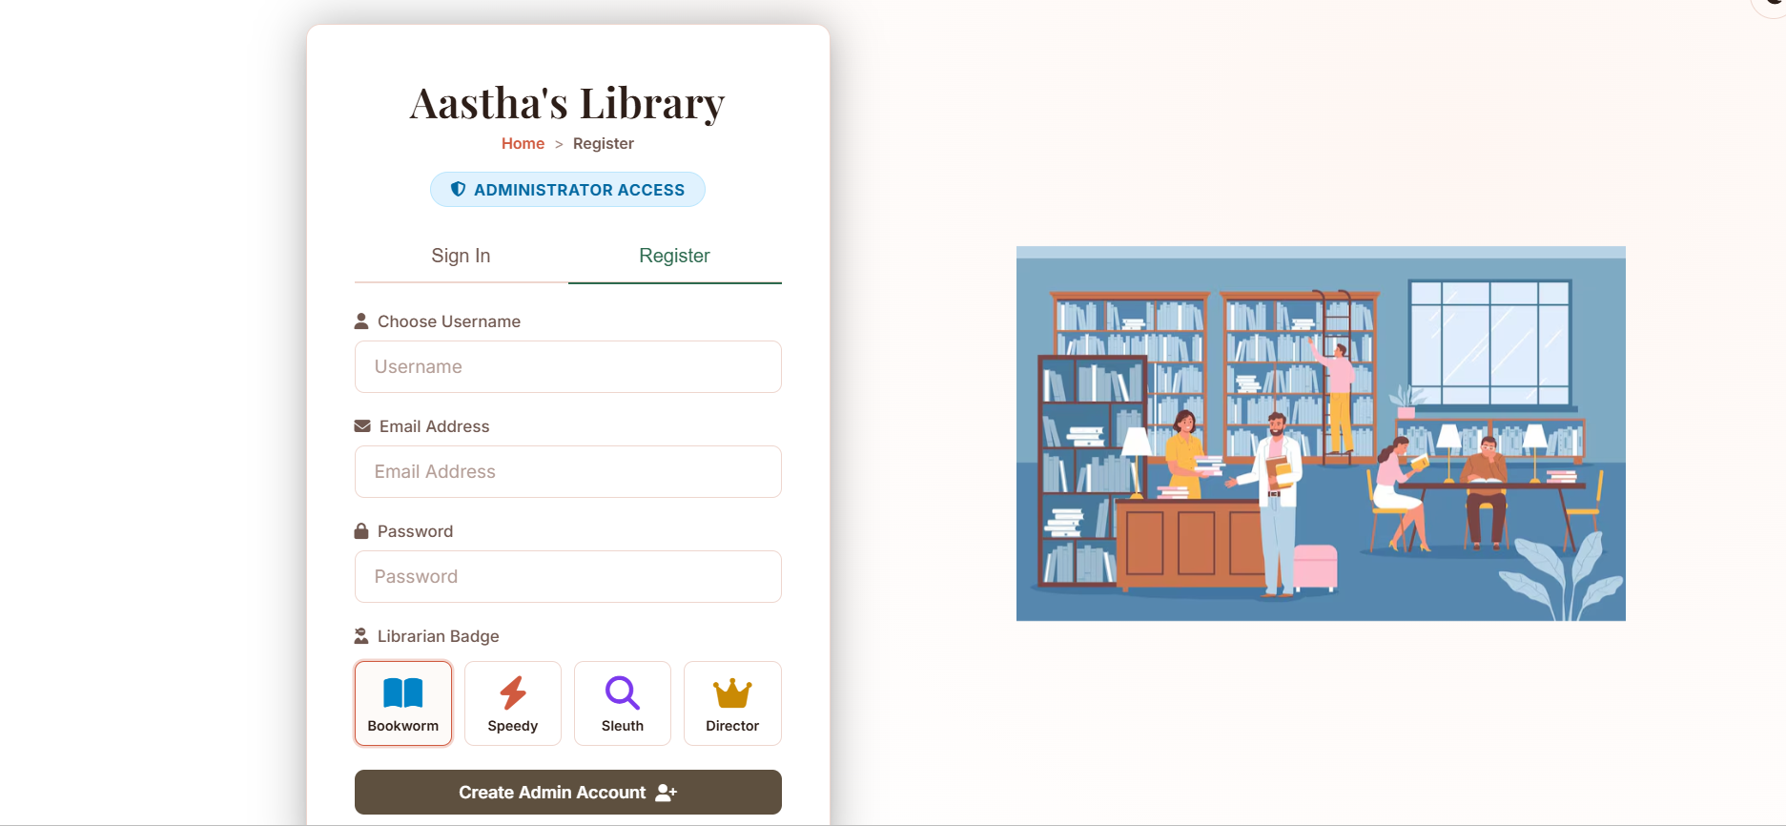

2. Implemented Functionalities
The system implements a full Model-View-ViewModel (MVVM) dashboard featuring four core administration desks:
- Dashboard Insights: Displays real-time counts for Total Books, Issued Books, Overdue Copies and Active Members alongside circulation percentages.
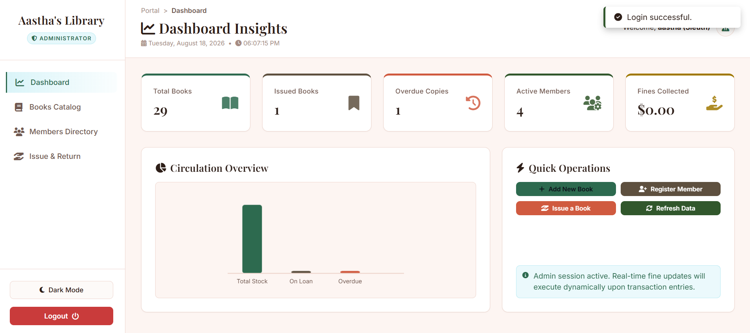
- Book Catalog Inventory: Supports catalog registry CRUD. Administrators can search books by Title, Author, Genre or ISBN, add new copies, adjust total stock and register bookshelf locations.
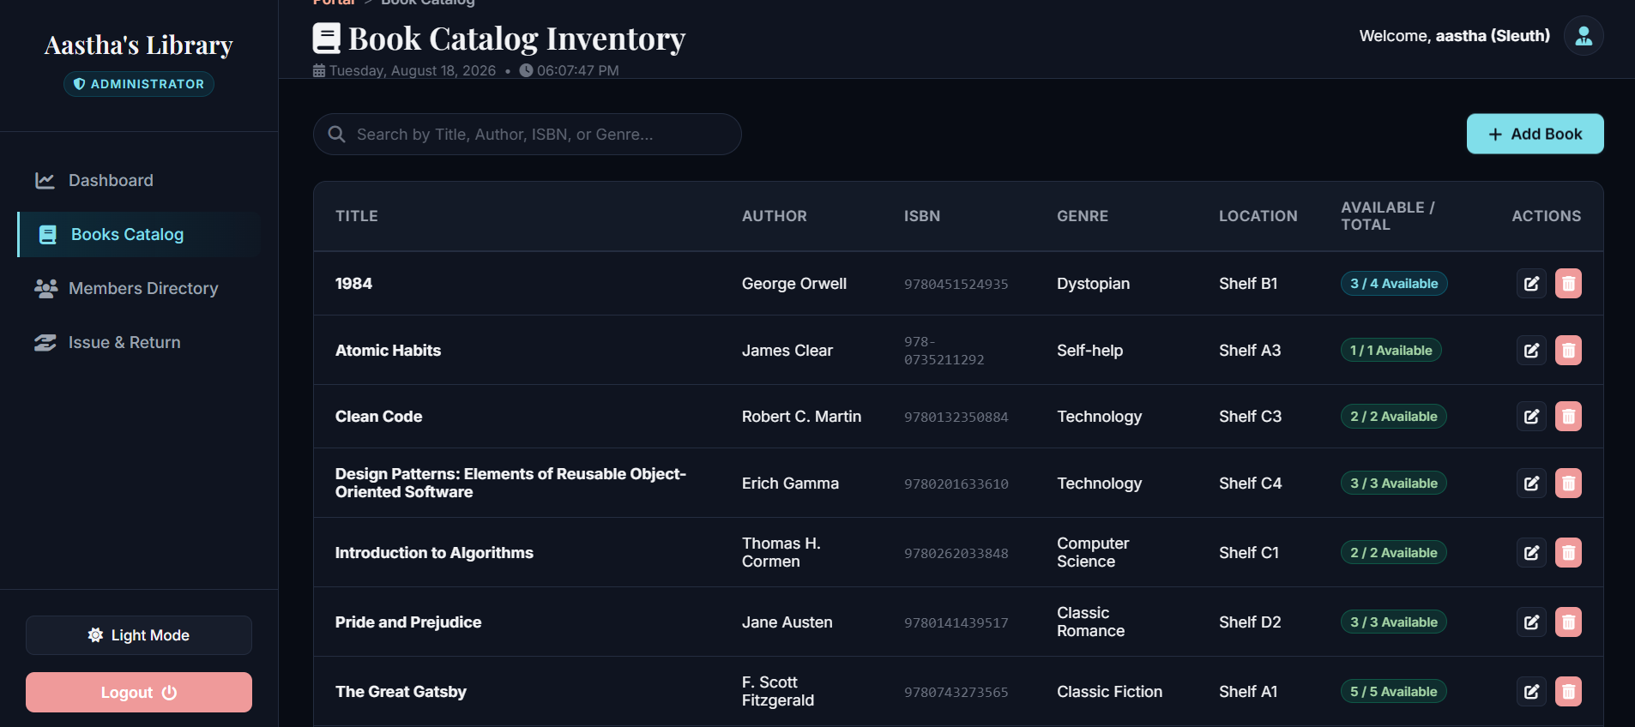
- Member Directory: Facilitates registration of cardholders, details contact emails/phones and supports account locks (toggling status between active and suspended to restrict borrows).
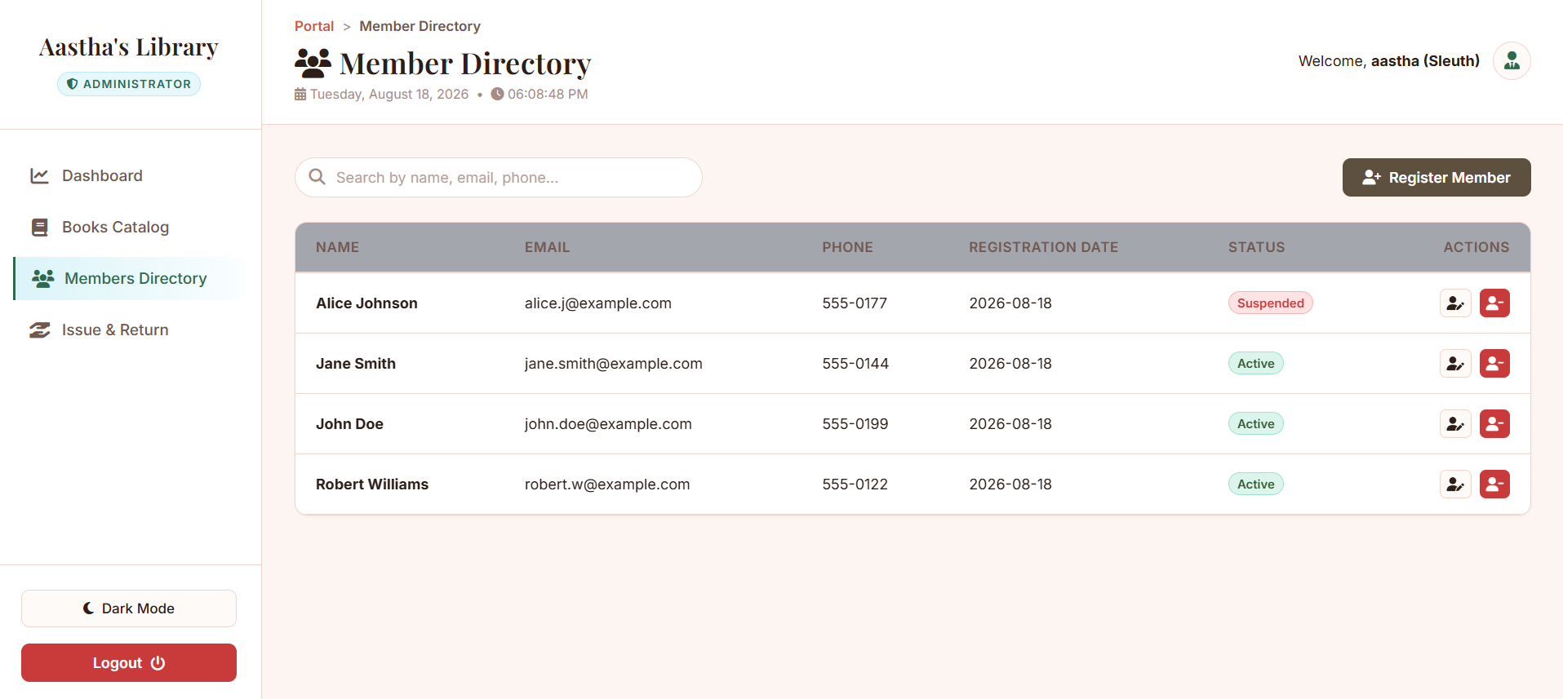
- Desk Circulation: Manages check-outs and returns. Automatically checks copy availability, enforces cardholder status locks, records issue/due timelines and dynamically calculates late fees at $2.00 per day upon return check-in.
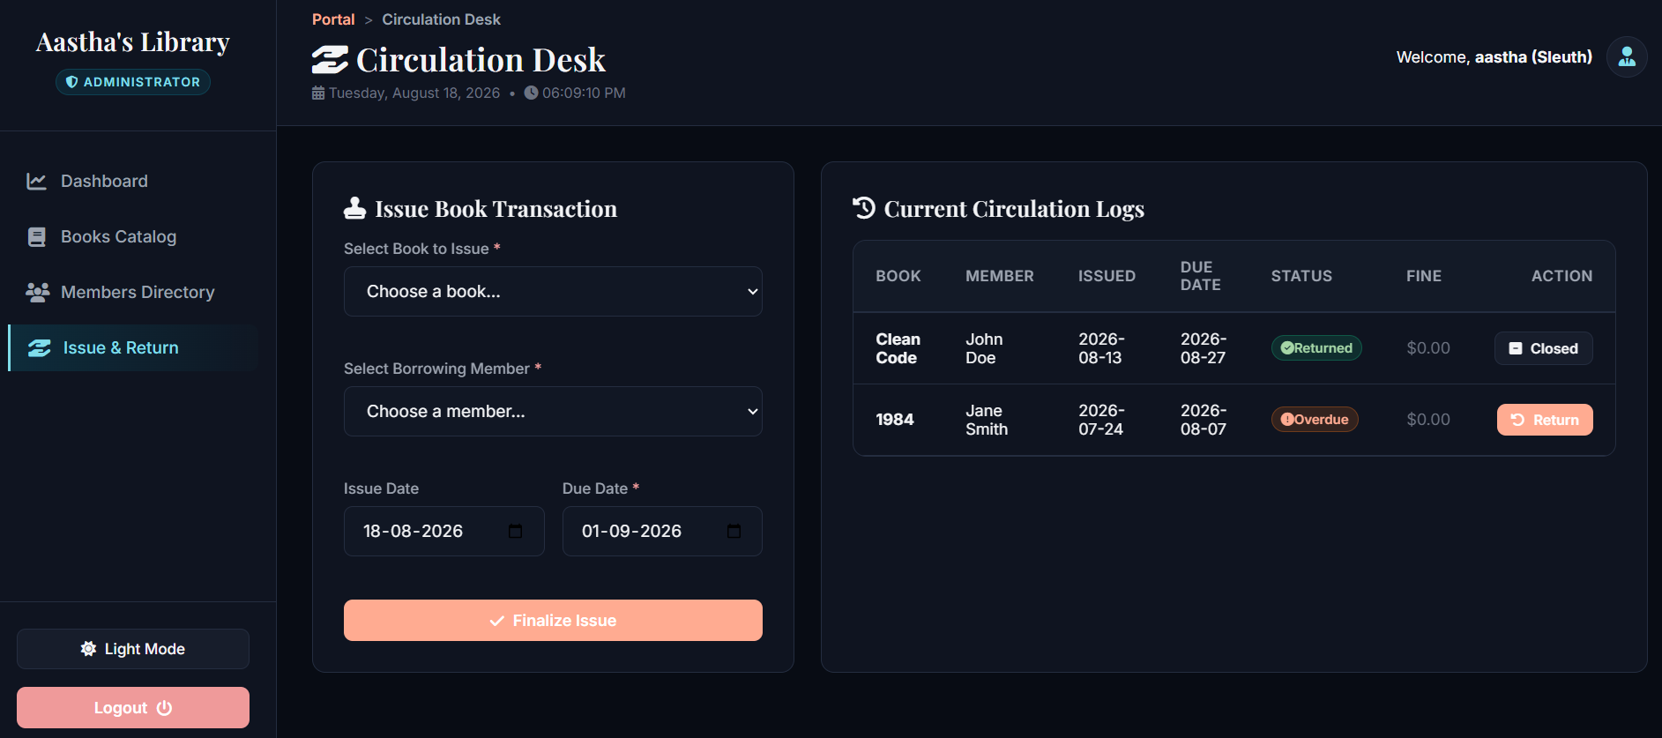

3. Class Names & Responsibilities (MVVM Architecture)
The application strictly enforces separation of concerns through MVVM layers:
Layer | File / Class Name | Primary Responsibility
Model | AuthModel (authModel.js) | Manages network authentication calls (session validation, login, registration, logout).
Model | BookModel (bookModel.js) | Performs API CRUD queries for adding, editing and deleting inventory items.
Model | MemberModel (memberModel.js) | Interfaces with member directory endpoints to retrieve list and create cardholders.
Model | BorrowModel (borrowModel.js) | Sends checkout requests, returning dates and fine calculations to endpoints.
ViewModel | AuthViewModel (authViewModel.js) | Intercepts sign-in form submissions, manages registration badges and controls routing redirects.
ViewModel | BooksViewModel (booksViewModel.js) | Handles add/edit dialog inputs, updates inventory data states and updates DOM catalog lists.
ViewModel | MembersViewModel (membersViewModel.js) | Orchestrates cardholder list updates, registration forms and account lock status updates.
ViewModel | BorrowViewModel (borrowViewModel.js) | Manages loan states, circulation list re-renders and checkout/return modal inputs.
ViewModel | DashboardViewModel (dashboardViewModel.js) | Refreshes landing statistics, binds KPI values to dashboard tiles and maintains the clock.
View | index.html / styles.css | Implements user interface elements, smooth-scroll navigations, variables themes and page reveals.

4. Important Methods / Functions
Below are the critical client-side and server-side methods driving circulation workflows:
Method Name | Location | Type | Purpose / Description
handleLogin(event) | authViewModel.js | JS (Client) | Authenticates credentials, saves librarian badges and redirects user to #dashboard.
loadBooks() | booksViewModel.js | JS (Client) | Fetches indexed inventory records and maps them to the DOM catalog table.
toggleMemberStatus(id) | membersViewModel.js | JS (Client) | Toggles member status (active vs suspended) to lock checkout operations.
issueBook(event) | borrowViewModel.js | JS (Client) | Triggers book issue queries to link a borrower ID to a book copy.
returnBook(recordId) | borrowViewModel.js | JS (Client) | Calculates overdue timelines, prompts dynamic late fees and marks records returned.
init_db() | Database (app/models.py) | Python (Server) | Initializes SQLite connection and generates schemas for database tables.
issue_book() | routes.py | Python (Server) | Performs transactional safety validations: checks book copy counts and verifies member status.
return_book(id) | routes.py | Python (Server) | Compares return date with due date and estimates fine amounts at $2.00/day.

5. Database Schema & Tables
The SQLite database file is stored in instance/library.db and is composed of four main tables:
Table 1: users (Librarian Accounts)
- id: INTEGER (Primary Key, Auto-increment)
- username: TEXT (Unique) — Used for admin authentication.
- email: TEXT — Admin contact address.
- password_hash: TEXT — Password hashed securely with scrypt.
- role: TEXT (Default: 'admin').
Table 2: books (Inventory Index)
- id: INTEGER (Primary Key, Auto-increment)
- title: TEXT — Title of the book.
- author: TEXT — Author name.
- isbn: TEXT (Unique) — International Standard Book Number.
- genre: TEXT — Book category.
- year: INTEGER — Publication year.
- copies_total: INTEGER — Total copies owned by the library.
- copies_available: INTEGER — Copies currently sitting on the shelf.
- location: TEXT — Bookshelf reference location.
Table 3: members (Cardholders Registry)
- id: INTEGER (Primary Key, Auto-increment)
- first_name: TEXT — First name of cardholder.
- last_name: TEXT — Last name of cardholder.
- email: TEXT (Unique) — Member email contact.
- phone: TEXT — Contact phone number.
- status: TEXT (Values: 'active', 'suspended') — Active checkouts locked if status is 'suspended'.
Table 4: borrow_records (Circulation Records)
- id: INTEGER (Primary Key, Auto-increment)
- book_id: INTEGER (Foreign Key referencing books.id)
- member_id: INTEGER (Foreign Key referencing members.id)
- issue_date: TEXT — Date book was checked out.
- due_date: TEXT — Date book must be returned.
- return_date: TEXT (Nullable) — Actual return check-in date.
- fine_amount: REAL (Default: 0.0) — Dynamic late return fees.
- status: TEXT (Values: 'issued', 'returned').

6. Connectivity Mapping (MVVM Integration)
The table below illustrates how the View, ViewModel, Model and Database connect to carry out key operations:
graph TD
View[index.html UI] -->|Event Trigger| VM[ViewModel Class]
VM -->|Fetch Request| Model[Model API Request]
Model -->|REST Endpoint| API[Flask Route Controller]
API -->|SQL Query| DB[(SQLite Tables)]
User Action (View) | Presenter VM Handler | Model Method (API Call) | Flask Server Route | DB Tables Involved | Resulting UI Update (View)
Click Sign In | authVM.handleLogin(e) | AuthModel.login(user, pass) | POST /api/auth/login | users | Hides auth cards, triggers page reveal, reveals sidebar.
Type in Search bar | booksVM.filterBooks(q) | (Local client filtering) | — | — | Displays matching row list.
Fill Add Book form | booksVM.createBook(e) | BookModel.create(data) | POST /api/books | books | Appends table row, triggers success alert popup.
Click Suspension Lock | membersVM.toggleStatus(id) | MemberModel.toggle(id) | PUT /api/members/<id> | members | Toggles status label colors between active (green) and suspended (red).
Click Issue Book | borrowVM.issue(e) | BorrowModel.issue(data) | POST /api/borrow/issue | books, members, borrow_records | Decrements available copies on UI, adds row to checkout index.
Click Return Book | borrowVM.return(recordId) | BorrowModel.return(id) | POST /api/borrow/return | books, borrow_records | Opens Return popup, renders return stats, updates copies totals.
Navigates View Hash | app.handleRouting() | (Dynamic View Loader) | — | — | Slides active pane, updates dynamic Breadcrumb trail links.

